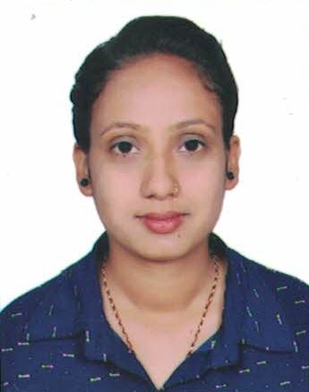

**CURRICULUM VITAE**

**AMRITA SAPKOTA**

Jorpati05, Kathmandu

Phone no:- 9860969461

Email Id:- [amreeta622@gmail.com](mailto:amreeta622@gmail.com)

# CAREER OBJECTIVE

* To build career in a growing organization, where I can get the opportunities to prove my abilities by accepting challenges, fulfilling the organizational goal and climb the career ladder through continuous learning and commitment.

# STRENGTH

* Hardworking
* Committed to duty and responsibility
* Positive attitude
* Ability to build and maintain through proper communication

# PERSONAL INFORMATION

Father’s Name : Ram Prasad Sapkota

Mother’s Name : Pabitra Sapkota Temporary Address : Jorpati 05,Kathmandu

Permanent Address : Jorpati 05,Kathmandu Date of Birth : 2055-05-18

Citizenship : 27-01-71-04605

Pan no. : 129553375

Gender : Female

Nationality : Nepalese

Marital status : Unmarried

Language : Nepali and English

**EDUCATION QUALIFICATION**

|  |  |  |  |  |
| --- | --- | --- | --- | --- |
| **Degree** | **Name of School/University** | **Board** | **Passed year** | **Division** |
| Bachelors | Pashupati Multiple Campus (Kathmandu,Nepal) | TU | 2020 | Second (51.75%) |
| Intermediate | Kumari Awasiya Higher Secondary School (Kathmandu,Nepal) | HSEB | 2016 | First (69.5%) |
| SLC | Samata Shikshya Niketan (Kathmandu,Nepal) | *Government of Nepal* | 2014 | First (73.25%) |

**EXPERIENCE**

* Paristhiti Multipurpose Cooperative Ltd, as a cashier since mangsir till now.

**Duties and responsibilities**

* Handling cash counter
* Arranging cash and doing tally with system at the end of the day
* Maintaining cash book and day book
* Generating cheque from system.
* Issuing passbook and verified that passbook from system.
* Doing customer registration ( KYC update)
* Opening A/C and many more.

**TRAINING & KNOWLEDGE**

* Computer knowledge (Advance ) from Famous Institutes
* Basic computer
* Office Packages(Microsoft word ,Excel, PowerPoint)
* Adobe Photoshop
* Tally ERP 9
* Infinity software

# SKILLS

* Quick decision making
* Quick Learning
* Analytical and problem solving
* Self-motivated
* Team working
* Can work in pressure
* Good Communication Skills.

**INTERESTS**

* Reading book
* Learning new things
* Visiting new place

# DECLERATION

* I hereby declare that the above information is true and correct to the best of my knowledge and belief.